BridgeU
Software Design Development

Zhiyi Pan 652115558

Bachelor of Science
Software Engineering Program

Department College of Arts,Media,and
Technology
Chiang Mai University
December 2025
Project Advisor
Asst. Prof. Pattama Longani, Ph.D.

Document History
Document  Name | Version | History | Status | Date | Editable | Reviewer
BridgeU-  SDD | BridgeU  SDD V.0.1 | Add Chapter1  • Purpose and  Scope  • User  Characteristics  • Acronyms and Definitions AddChapter2  • Software  Architecture  AddChapter3  Progress1  • Detail Design  • Class Diagram• Sequence  Diagram  Add Chapter 4  Progress1  • UI | Draft | 12/12/2025 | ZHIYI PAN | Asst. Prof. Pattama Longani, Ph.D.

Table Content
Chapter 1 Introduction 4
1.1 Purpose and Scope 4
1.2 Acronyms and Definitions 4
Chapter 2 System Architecture 7
Chapter 3 Detail Design 8
3.1 Feature 1 8
3.1.1 Class Diagram 8
3.1.2 Class Diagram Description 9
3.1.3 Sequence Diagram 24

Chapter 1 Introduction

Purpose and Scope
The purpose of the software design development is to present a complete software design of the BridgeU project. This document contains the outline of the software architecture, functions used, and activity diagrams with the user interface for this project. BridgeU aims to eliminate language barriers through AI technology and establish a bilingual mutual assistance ecosystem connecting Chinese students, global students, and local Thai merchants.

Acronyms and Definitions
Acronyms
SRS | Software Requirement Specification
UI | User Interface
SDD | Software Design Document
FD | Function Description

Name | Definition
IEEE | Institute for Electrical and Electronics Engineers. Biggest global interest  group for engineers of different branches and computer scientists.
Plan | A document series of tasks requires meeting an objective, typically  including the associated schedule, budget, resources, organizational  description and work breakdown structure.
Feature | Feature Transformation of input parameters to output parameters based  on a specified algorithm. It describes the functionality of the product in  the language of the product. Used for requirements analysis, design,  coding, testing or maintenance.
Project  Management | The application of knowledge, skills, tools, and techniques to project  activities in order to meet or exceed stakeholder needs and expectations  from a project.
Project Plan | A formal, approved document used to guide both project execution and  project control. The primary uses of the project plan are to document  planning assumptions and the decision, to facilitate communication  among stakeholders, and to document approved scope, cost, and  schedule baseline.
Risk | An uncertain event or condition that, if it occurs, has a positive or  negative effect on a project’s objectives. It is a function of the  probability of occurrence of a given threat’s occurrence.
Risk Management | The systematic application of management policies, procedures and  practices to the tasks of identifying, analyzing, evaluating, treating and  monitoring risk.
System Testing | Testing conducted on a complete and integrated system for evaluate the  system’s compliance with its specified requirements.
Unit Test | A test of individual programs or modules in order to remove a design or  programming errors.
Traceability | The ability to trace the history, application or location of an item or  activity, or work products or activities, by means of recorded  identification. The establishment and maintenance of relationships  between such items. Horizontal traceability describes the relationship  between work products of the same type (e.g. Customer requirements).  Vertical traceability describes the relationship between work products,  which build or derived from each other (e.g., from customer  requirements to qualification test cases). Bidirectional traceability  allows to directly following relationships in both directions.
Use Case | A use case is a description of a specific interaction between a system  and its users to accomplish a particular goal or task. It outlines the  sequence of steps or actions that a user performs in the system and  describes the system's responses to those actions. Use cases help to  identify and define the functional requirements of a system from the  perspective of its users.
Crawler | A program that systematically browses the World Wide Web in order to create an index of data.
Qwen AI | he Large Language Model provided by Alibaba Cloud used for translation and summarization.

Chapter 2 System Architecture
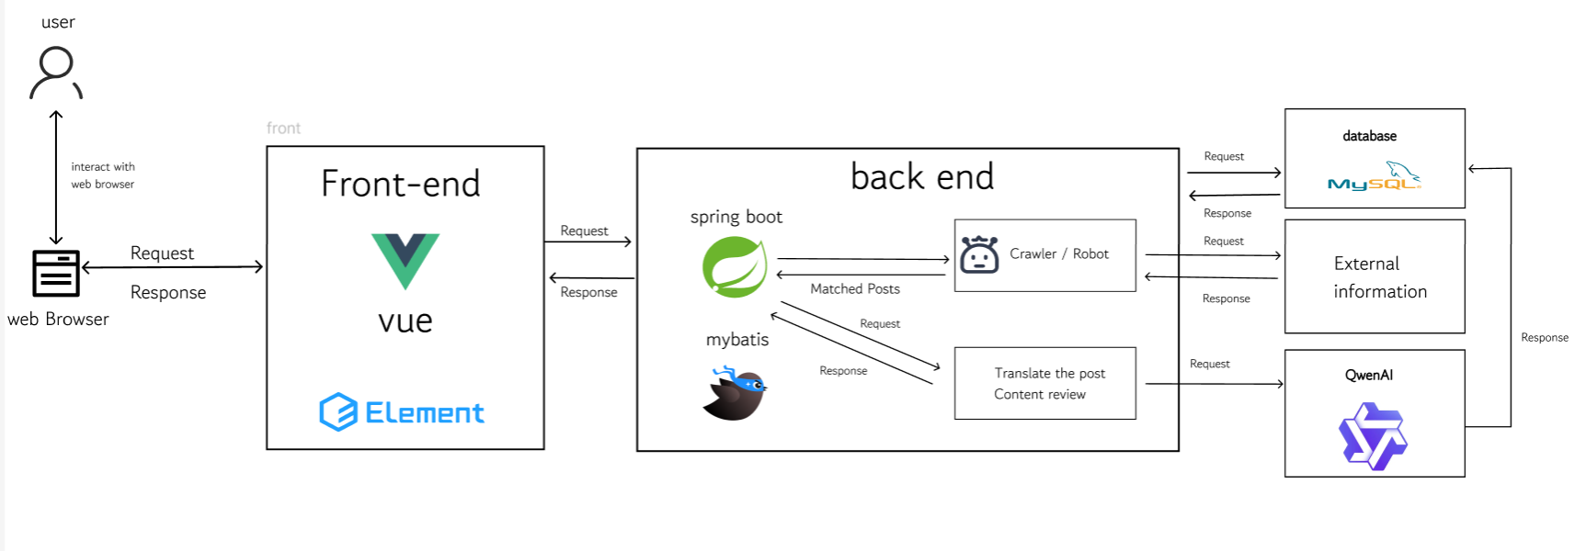

Description:
The system architecture consists of a front-end built using Vue.js 2 and Element UI, which provides a responsive user interface. The back-end is built with Spring Boot, a robust Java framework, handling business logic and RESTful API requests. MySQL 8 is used as the primary database for storing structured user and post data. Elasticsearch is integrated to provide high-performance semantic search capabilities. Additionally, the system connects to the Aliyun Qwen API to perform natural language processing tasks such as summarization and translation. Axios is used for communication between the front-end and back-end.

Chapter 3 Detail Design

3.1 Feature 1

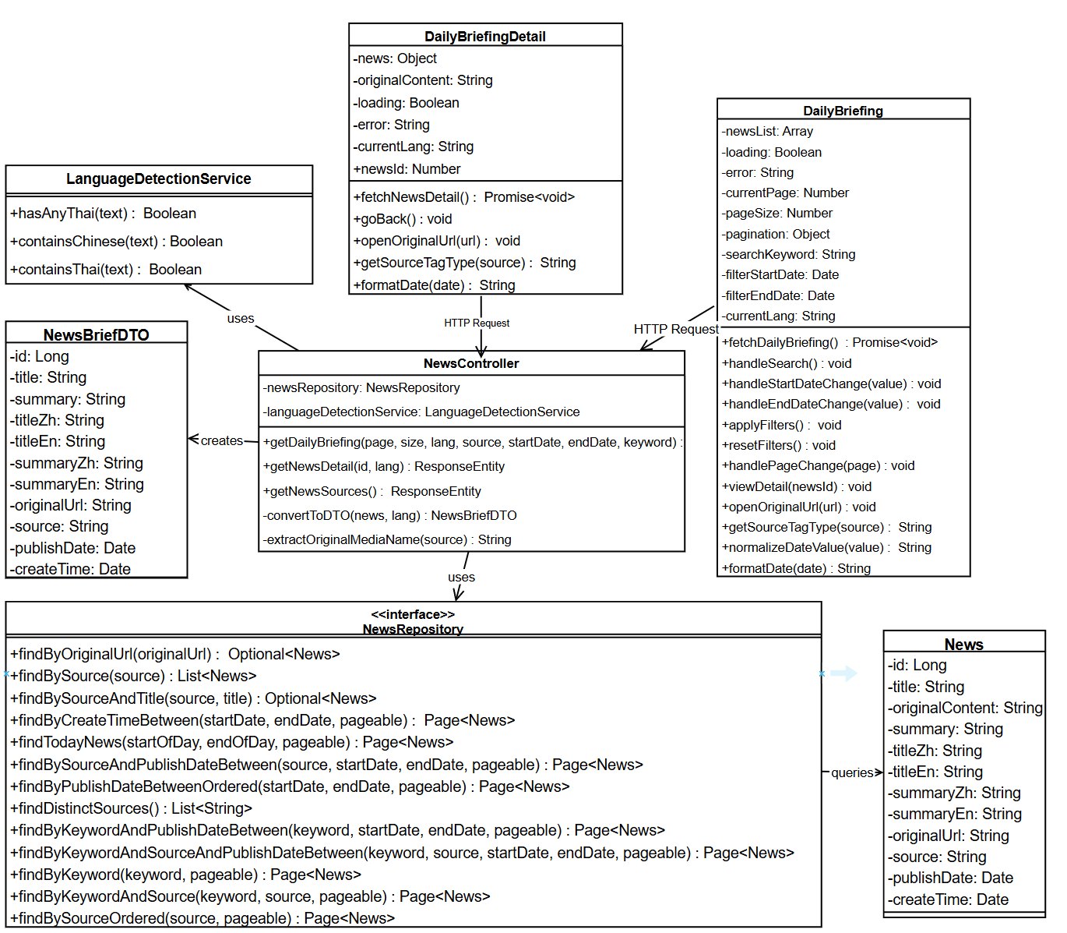
3.1.1 Class Diagram

3.1.2 Class Diagram Description

3.1.2.1 View

3.1.2.1.1 DailyBriefing
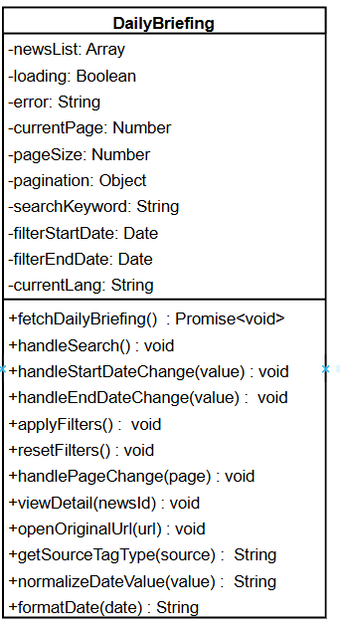

Attributes:
ID | Name | Description | Type
1 | newsList | Array containing the list of Daily Briefing news items to be displayed | Array
2 | loading | Boolean flag indicating if the news data is currently being fetched | Boolean
3 | error | String containing error message if data fetching fails | String
4 | currentPage | Current page number for pagination (1-based) | Number
6 | pageSize | Number of news items to display per page | Number
7 | searchKeyword | String containing the keyword entered by the user for searching news | String
8 | filterStartDate | Date object representing the start date for filtering news by publication date | Date
9 | filterEndDate | Date object representing the end date for filtering news by publication date | Date
10 | currentLang | String representing the current interface language ("zh" for Chinese, "en" for English) | String

Methods:
ID | Name | Description | Parameter | Return Type
1 | fetchDailyBriefing | Fetches Daily Briefing news items from the backend API with pagination, search, and filter parameters. Handles loading state and errors. | None | Promise<void>
2 | handleSearch | Handles search action by resetting current page to 1 and calling fetchDailyBriefing | None | Void
3 | handleStartDateChange | Updates the filterStartDate when user selects a start date | value: Date \null | void
4 | handleEndDateChange | pdates the filterEndDate when user selects an end date | value: Date \null | void
5 | applyFilters | Validates date range and applies filters by resetting current page to 1 and calling fetchDailyBriefing | None | void
6 | resetFilters | Clears all filter conditions (search keyword, start date, end date) and resets pagination to page 1 | None | void
7 | handlePageChange | Handles pagination by updating currentPage and fetching the corresponding page of news | page: Number | void
8 | viewDetail | Emits an event to navigate to the news detail page for a specific news item | newsId: Number | void
9 | openOriginalUrl | Opens the original news article URL in a new browser tab | url: String | void
10 | getSourceTagType | Returns the Element UI tag type (primary/success/info) based on the news source | source: String | String
11 | normalizeDateValue | Normalizes date value (Date object or string) to DD-MM-YYYY format string | value: Date \String | String \null
12 | formatDate | Formats a date object to "DD-MM-YYYY HH:mm" format string | date: Date \String | String

3.1.2.1.2 DailyBriefingDetail
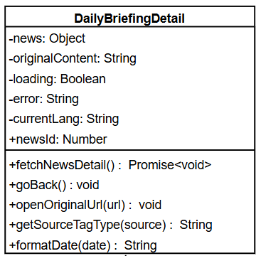
Attributes:
ID | Name | Description | Type
1 | news | Object containing the detailed information of a single Daily Briefing news item | Object
2 | originalContent | String containing the original content of the news article | String
3 | loading | Boolean flag indicating if the news detail data is currently being fetched | Boolean
4 | error | String containing error message if data fetching fails | String
5 | currentLang | String representing the current interface language ("zh" for Chinese, "en" for English) | String
6 | newsId | Number representing the ID of the news item to display (passed as prop) | Number

Methods:
ID | Name | Description | Parameter | Return Type
1 | fetchNewsDetail | Fetches detailed information of a single news item from the backend API using newsId. Handles loading state and errors. | None | Promise<void>
2 | goBack | Emits an event to navigate back to the Daily Briefing list page | None | Void
3 | openOriginalUrl | Opens the original news article URL in a new browser tab | url: String | Void
4 | getSourceTagType | Returns the Element UI tag type (primary/success/info) based on the news source | source: String | String
5 | formatDate | Formats a date object to "DD-MM-YYYY HH:mm" format string | date: Date \String | String

3.1.2.2 Controller

3.1.2.2.1 Controller: NewsController
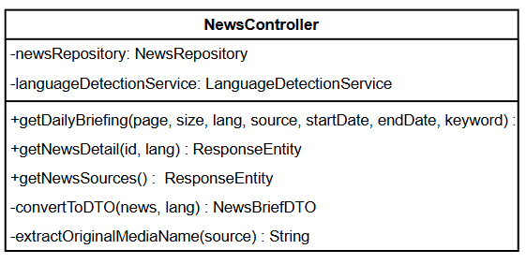
Attributes:
ID | Name | Description | Type
1 | newsRepository | Instance of NewsRepository for database operations | NewsRepository
2 | languageDetectionService | Instance of LanguageDetectionService for detecting Thai and Chinese content | LanguageDetectionService

Methods:
ID | Name | Description | Parameter | Return Type
1 | getDailyBriefing | Handles GET request to retrieve paginated Daily Briefing news list with optional filters (keyword, date range, source). Returns ResponseEntity with paginated news data. | page: int, size: int, lang: String, source: String, startDate: String, endDate: String, keyword: String | ResponseEntity<Map<String, Object>>
2 | getNewsSources | Handles GET request to retrieve detailed information of a single news item by ID. Returns ResponseEntity with news detail data. | id: Long, lang: String | ResponseEntity<Map<String, Object>>
3 | getNewsSources | Handles GET request to retrieve list of distinct news sources. Returns ResponseEntity with list of source names. | None | ResponseEntity<Map<String, Object>>
4 | convertToDTO | Converts News entity to NewsBriefDTO based on language preference. Ensures no Thai content is displayed on the website. | news: News, lang: String | NewsBriefDTO
5 | extractOriginalMediaName | Extracts original media name from source string (e.g., "Google News (Thailand) - Bangkok Post" -> "Bangkok Post") | source: String | String

3.1.2.3 Repository

3.1.2.3.1 Repository: NewsRepository
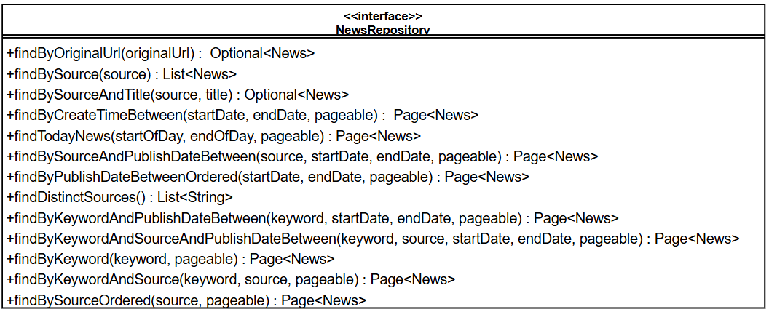
Methods:
ID | Name | Description | Parameter | Return Type
1 | findByOriginalUrl | Finds a news item by its original URL (for deduplication) | originalUrl: String | Optional<News>
2 | findBySource | Finds all news items by source website name | source: String | List<News>
3 | findBySourceAndTitle | Finds a news item by source website name and title | source: String, title: String | Optional<News>
4 | findByCreateTimeBetween | Finds news items within specified date range based on createTime (with pagination) | startDate: Date, endDate: Date, pageable: Pageable | Page<News>
5 | findTodayNews | Finds today's news items based on publishDate (with pagination) | startOfDay: Date, endOfDay: Date, pageable: Pageable | Page<News>
6 | findBySourceAndPublishDateBetween | Finds news items by source and publish date range (with pagination) | source: String, startDate: Date, endDate: Date, pageable: Pageable | Page<News>
7 | findByPublishDateBetweenOrdered | Finds news items within publish date range, ordered by publishDate DESC (with pagination) | startDate: Date, endDate: Date, pageable: Pageable | Page<News>
8 | findDistinctSources | eturns list of distinct news source names | None | List<String>
9 | findByKeywordAndPublishDateBetween | Searches news items by keyword (in title, content, summary, translations) and publish date range (with pagination) | keyword: String, startDate: Date, endDate: Date, pageable: Pageable | Page<News>
10 | findByKeywordAndSourceAndPublishDateBetween | Searches news items by keyword, source, and publish date range (with pagination) | keyword: String, source: String, startDate: Date, endDate: Date, pageable: Pageable | Page<News>
11 | findByKeyword | Searches news items by keyword across all historical news (with pagination) | keyword: String, pageable: Pageable | Page<News>
12 | findByKeywordAndSource | Searches news items by keyword and source across all historical news (with pagination) | keyword: String, source: String, pageable: Pageable | Page<News>
13 | findBySourceOrdered | Finds news items by source, ordered by publishDate DESC (with pagination) | source: String, pageable: Pageable | Page<News>

3.1.2.4 Model

3.1.2.4.1 Model: News
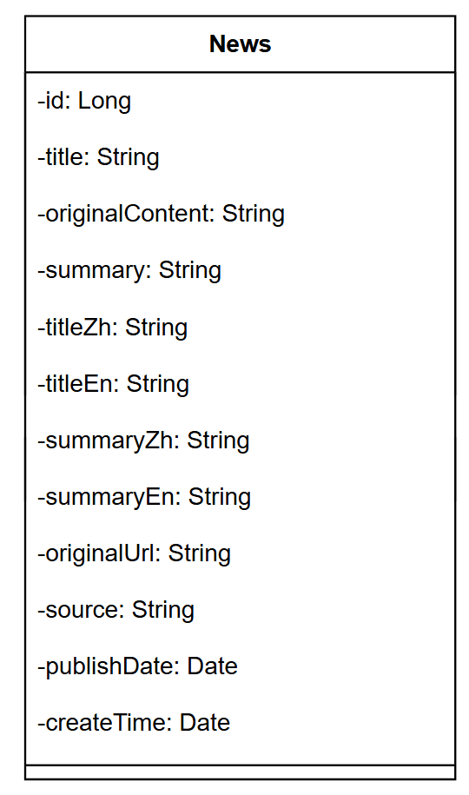
Attributes:
ID | Name | Description | Type
1 | Id | Primary key ID of the news item | Long
2 | title | Original news title | String
3 | originalContent | Original content of the news article (stored as TEXT) | String
4 | summary | AI-generated summary of the news article | String
5 | titleZh | Chinese translation of the title | String
6 | titleEn | English translation of the title | String
7 | summaryZh | Chinese translation of the summary | String
8 | summaryEn | English translation of the summary | String
9 | originalUrl | Original article URL from the source website | String
10 | source | Source website name | String
11 | publishDate | Publication date from the source website | Date
12 | createTime | imestamp when the news was crawled and stored | Date

3.1.2.4.2 Model: NewsBriefDTO
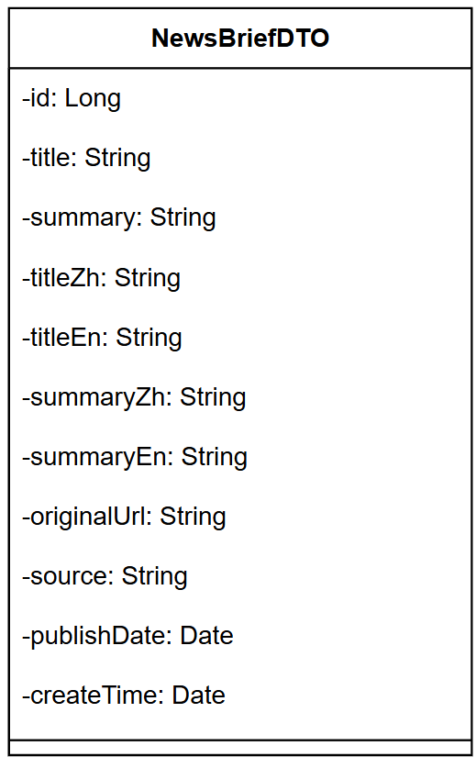
Attributes:
ID | Name | Description | Type
1 | Id | Primary key ID of the news item | Long
2 | Title | news title (language-specific based on user preference) | String
3 | Summary | news summary (language-specific based on user preference) | String
4 | titleZh | Chinese translation of the title | String
5 | titleEn | English translation of the title | String
6 | summaryZh | Chinese translation of the summary | String
7 | summaryEn | English translation of the summary | String
8 | originalUrl | Original article URL from the source website | String
9 | source | Source website name | String
10 | publishDate | Publication date from the source website | Date
11 | createTime | Timestamp when the news was crawled and stored | Date

3.1.3 Sequence Diagram
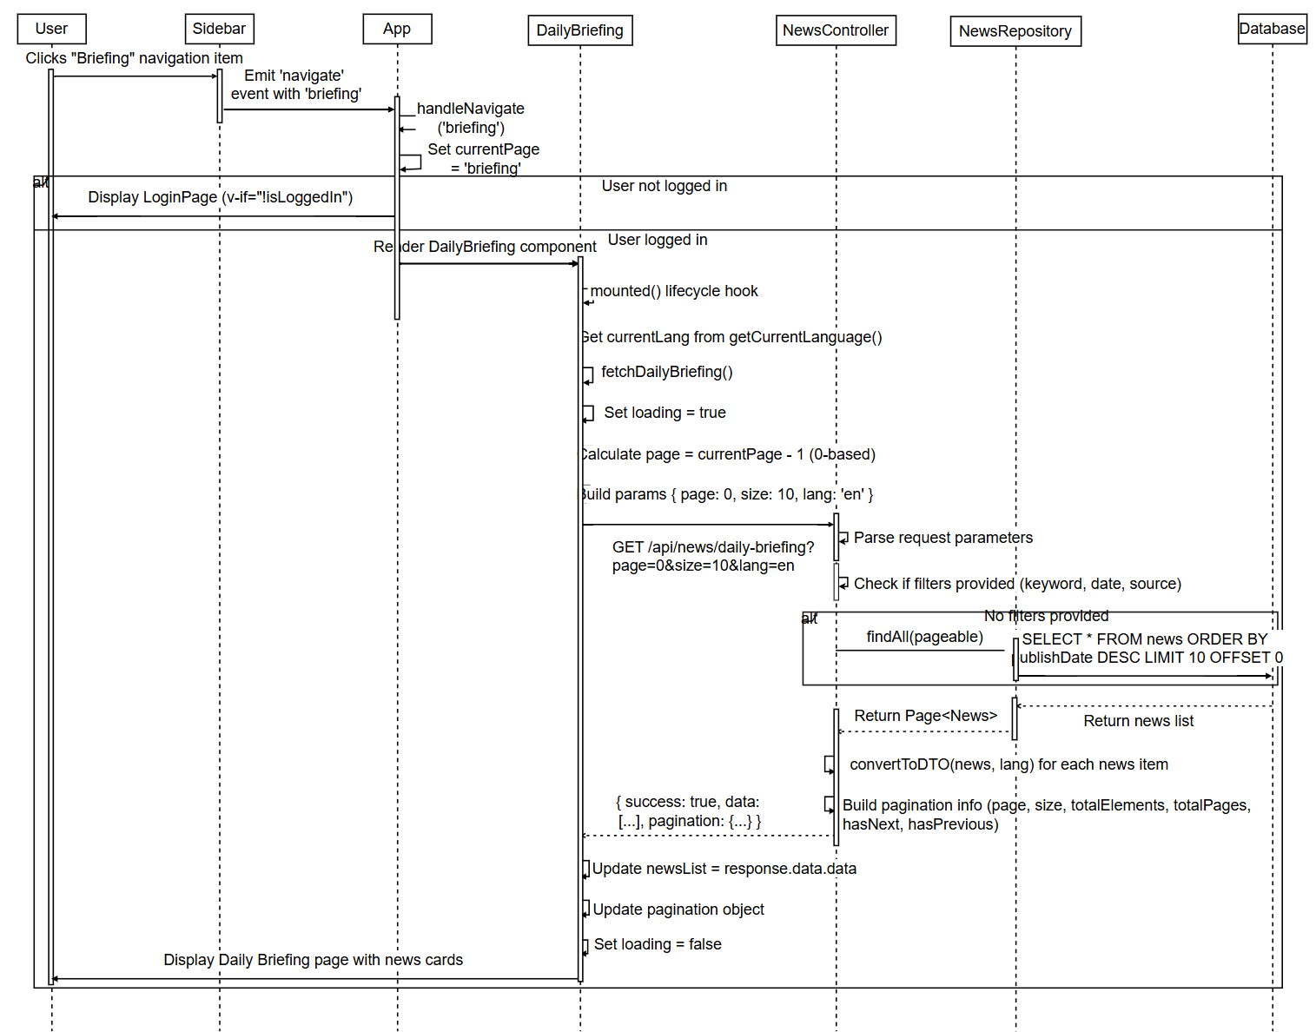
SD-01：View Daily Briefings

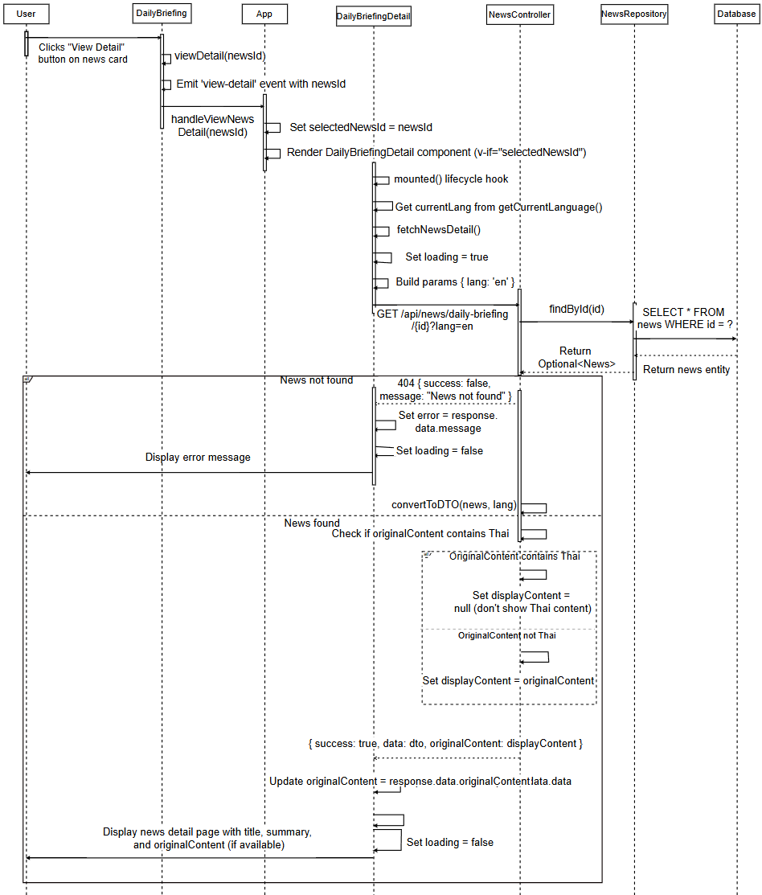
SD-02: View Daily Briefing News Details
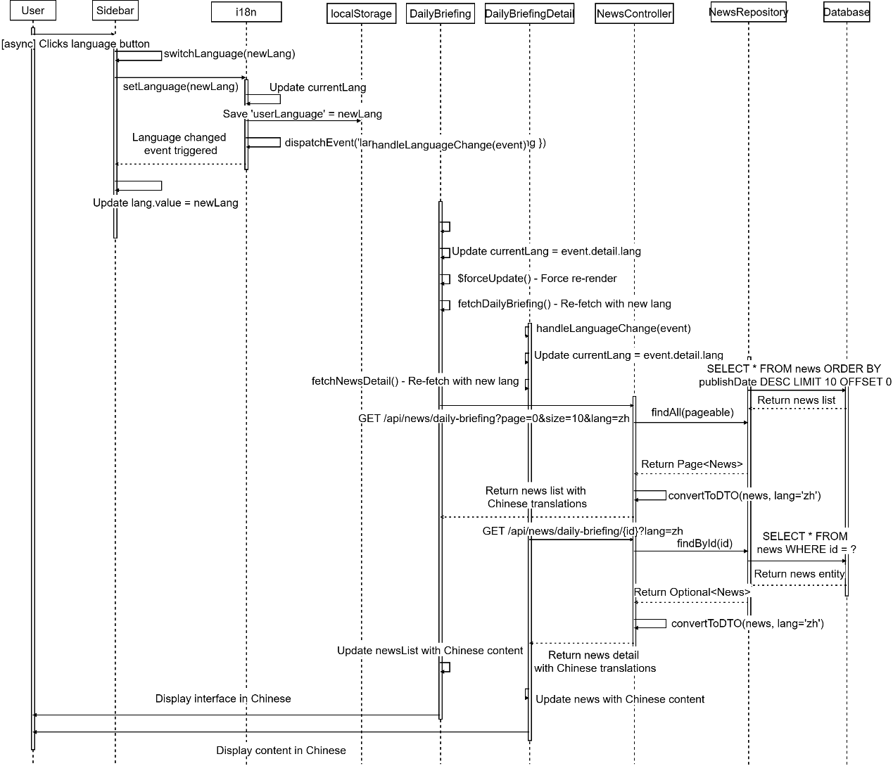
SD-03: Switch Interface Language

SD-04: Jump to Original Link
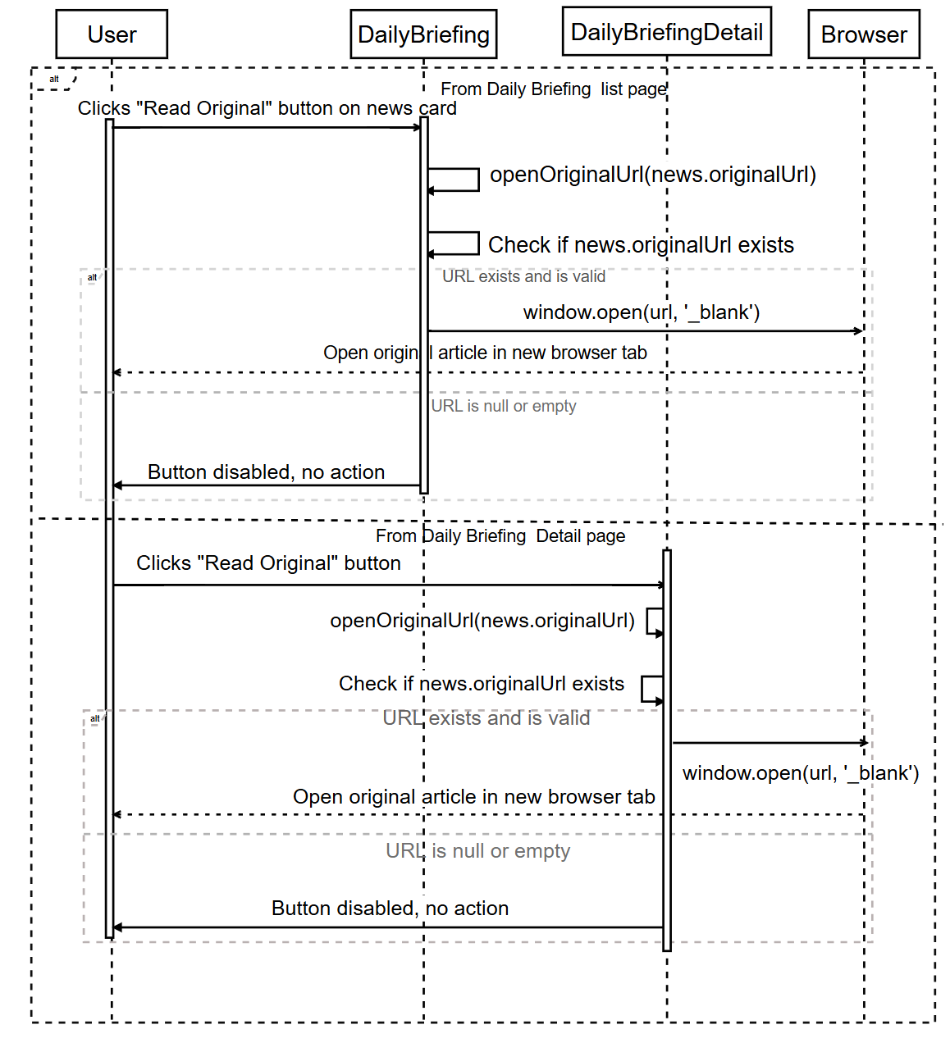

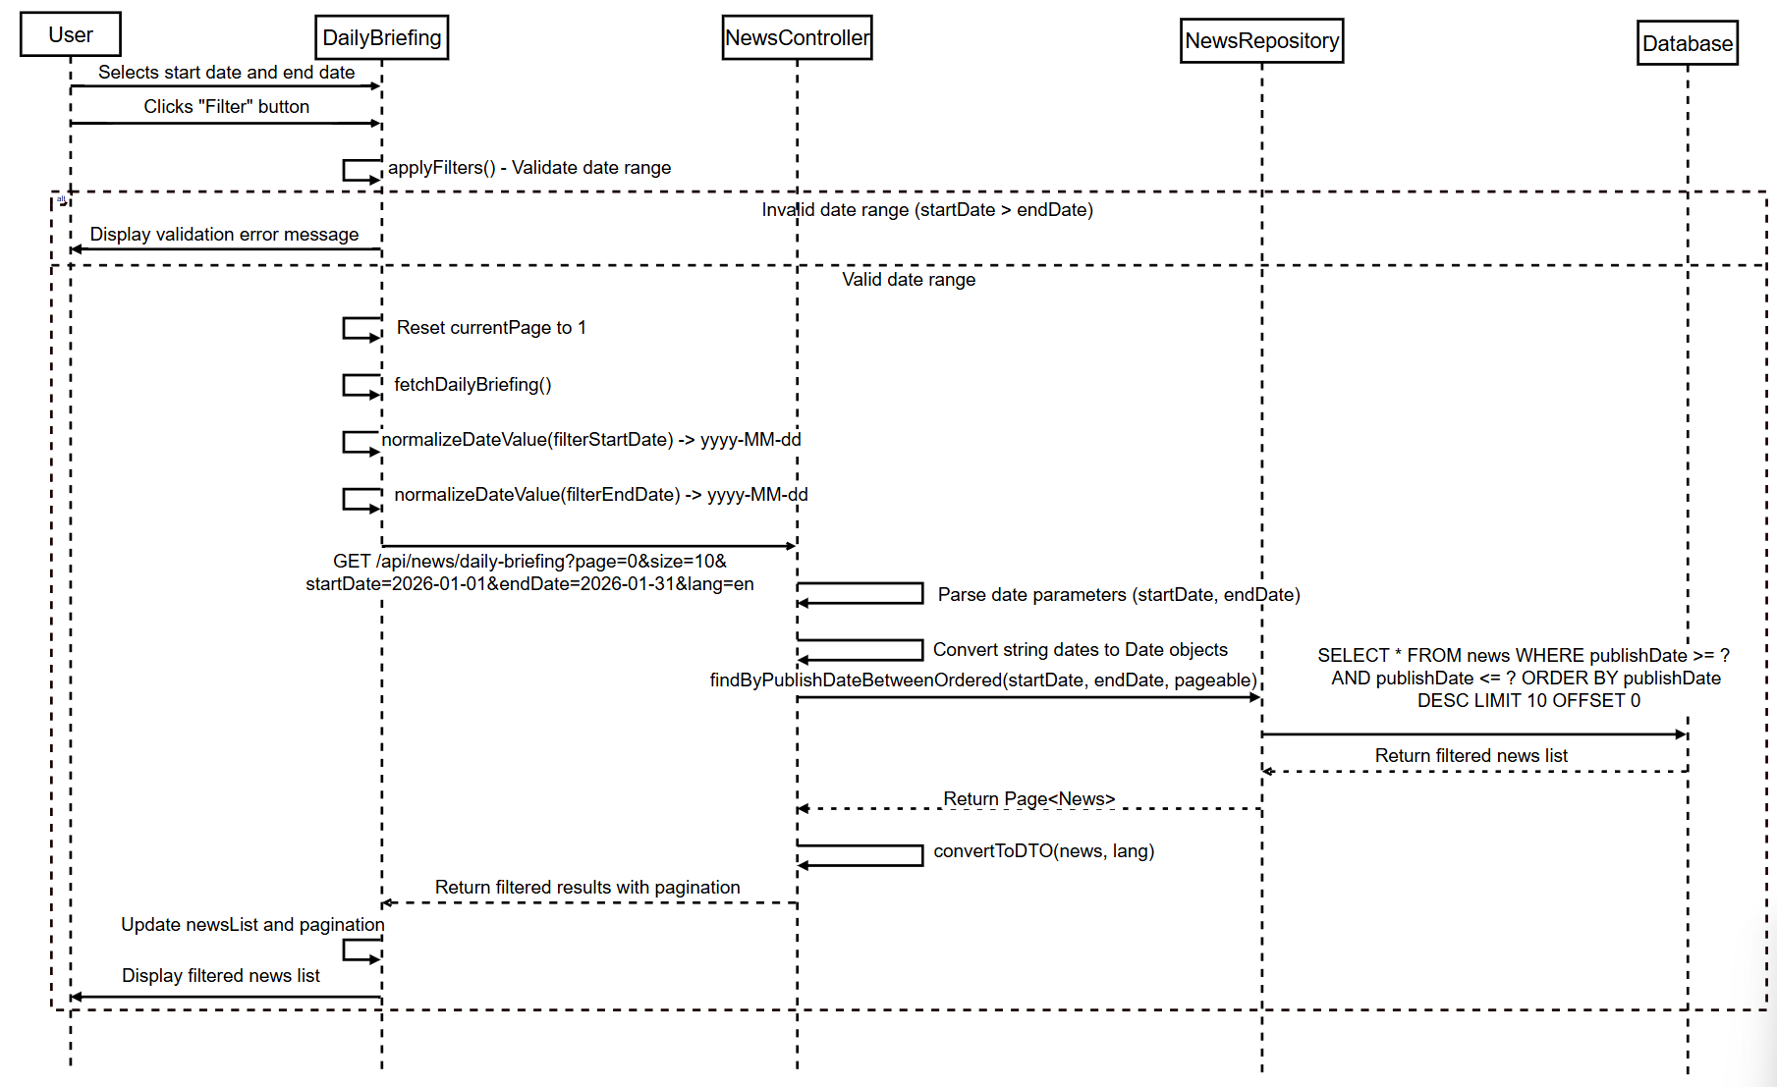
SD-05: Filter Daily Briefing News by Date

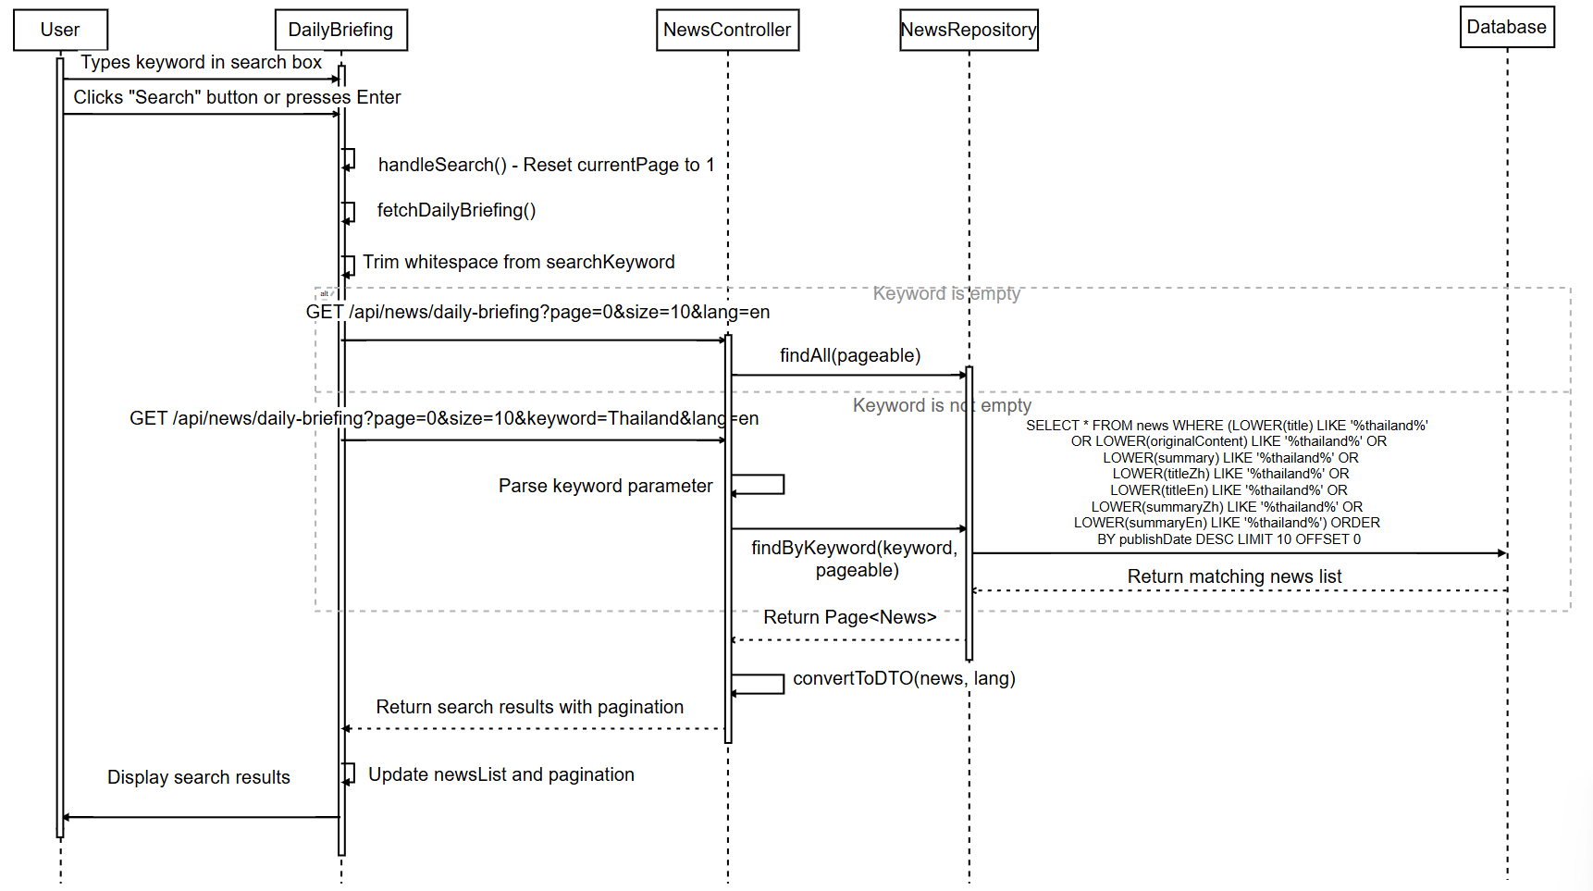
SD-06: Search Daily Briefing News

